Final Year Project Proposal
Title of the Project: | Facial recognition door
Supervisor Name & Contact Details: | Anthony T Kelly  +353 14024906  Anthony.kelly@tudublin.ie  Web
Objective: | The main goal is to build an automated door that unlocks itself using facial recognition.
Course: | DT008/3 – Electronic & communication engineering
Project Description (max 200 words):
I was interested in an automated door lock that opens itself without using a key lock. This device doesn’t have those major drawbacks in the common door look. Anyone can open a common door lock by duplicating or stealing the key and, it’s simply impossible if we want our friends and family to enter our house, without being present over there.
This smart lock can open whenever we turn up in front of the gate or whenever we want it to be opened for someone else without being physically present at the door.

The owner can operate the pi camera on a computer and have to add and take multiple photographs of the people, once the face is recognised by the classifier based on the pre-stored image library, the image will be sent to a remote console waiting for the owner’s decision. Depending on the owner’s decision, Raspberry pi will process and recognised their faces and give them access to enter the house or tell them to step away from the door depending on the decision from the owner.
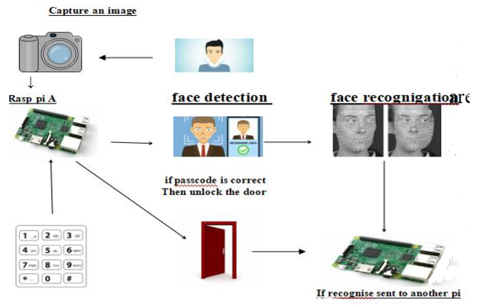

Hardware components:
- Raspberry Pi 2 Model B
- Breadboard
- 12-volt DC electric door strike
- Female dc power adapter
- 12-volt power supply
- Camera
- Speakers
- On/Off button
Design structure parts:
- Wood
- Lock
- Brackets
Software apps and online services:
- Python
- Microsoft Visual studio
- Microsoft Azure
- Microsoft Windows 10 IOT core

References
[1] Jie-Ci Yang et. all An Intelligent Automated Door Control System Based on a Smart Camera.
[2] S. Nazeem Basha et all An Intelligent Door system using Raspberry pi and Amazon Web services IOT.
[3] Richard Grimmett, Raspberry Pi Robotic Projects. Packt Publishing.

Key Outcomes:
(main milestones and sub-goals of the project; include learning outcomes and research areas)
To recognise face using digital image processing
Face recognition using line edge map
Save database of the face samples and keep updating each time the face is recognised
Lock/unlock the door with facial recognition
Risk Assessment Category: | (See Undergraduate Project Risk Assessment Form)
Main Project Themes: (tick up to three that apply)
Hardware Design |  | Y
Software Design |  | Y
Mathematical Methods
Circuit Building |  | Y
Modelling / Simulation
Analysis
Industrial Collaboration
Multidisciplinary
Other (please specify)

